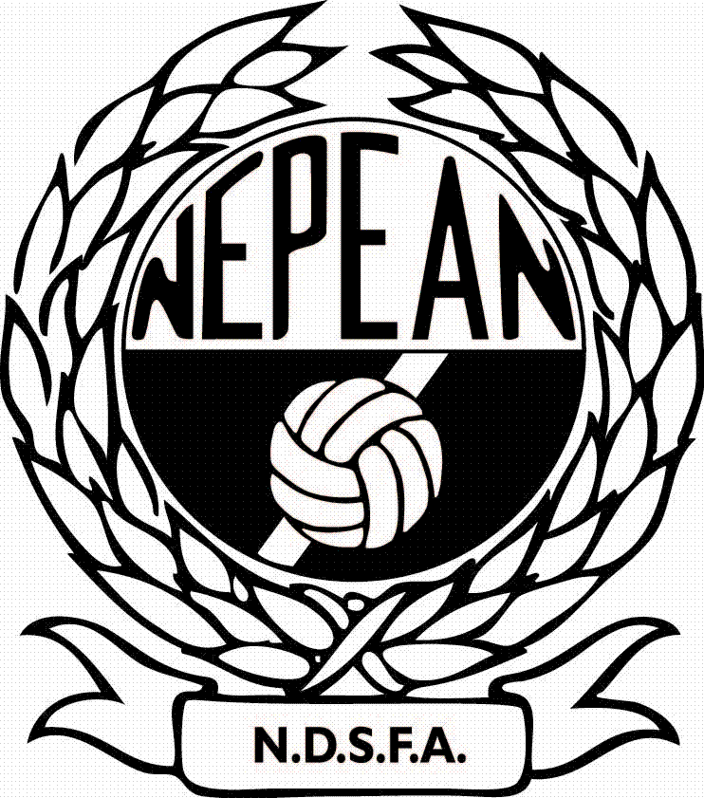

NEPEAN DISTRICT SOCCER TABLE OF OFFENCE CODES

CLUB RESOURCES FOR VOLUNTEER/UNOFFICIAL REFEREES

Please use the following Yellow & Red Card offence codes when completing team sheets and send off reports.

 | OFFENCE
Y1 | Is guilty of unsporting behaviour
Y2 | Shows dissent by word or action
Y3 | Persistently infringes the Laws of the Game
Y4 | Delays the restart of play
Y5 | Fails to retreat the required distance when play is restarted with a corner kick, free kick or throw-in
Y6 | Enters or re-enters the field of play without the Referee’s permission
Y7 | Deliberately leaves the field of play without the Referee’s permission

 | OFFENCE
R1 | Is guilty of serious foul play
R2 | Is guilty of violent conduct
R3 | Spits at an opponent or any other person
R4 | Denies the opposing team a goal or an obvious goal scoring opportunity by deliberately handling the ball (this does not apply to a goalkeeper within his or her own penalty area)
R5 | Denies an obvious goal scoring opportunity to an opponent moving towards the player’s goal by an offence punishable by a free kick or a penalty kick
R6 | Uses offensive or insulting or abusive language and/or gestures
R7 | Receives second caution in the same Match

If a player is dismissed from the field of play or receives a caution during a match, please use the above codes to record the send off or caution on both the team sheet and the send off report form.

SEND OFF REPORT FOR UNOFFICIAL REFEREES
NEPEAN DISTRICT SOCCER FOOTBALL ASSOC. INC.

To: P. & D.C. Chairman, Date: / /

During a match between:

vs
(Insert Team Names)

Div. Competition.
(age of teams)

Played at: on:
(insert name of field) (insert date played)

I have to report that I sent from the field of play:
(Players Name)

Shirt No.: Registration No.:

of: (Club Name) for: (Tick appropriate box)

 |  | RED CARD (SEND OFF) OFFENCE CODE
 | R1 | Is guilty of serious foul play
 | R2 | Is guilty of violent conduct
 | R3 | Spits at an opponent or any other person
 | R4 | Denies the opposing team a goal or an obvious goal scoring opportunity by deliberately handling the ball (this does not apply to a goalkeeper within his or her own penalty area)
 | R5 | Denies an obvious goal scoring opportunity to an opponent moving towards the player’s goal by an offence punishable by a free kick or a penalty kick
 | R6 | Uses offensive or insulting or abusive language and/or gestures
 | R7 | Receives second caution in the same Match

The incident which came under my notice was as follows: (If insufficient space please attach continuting report)

In the minute of the game:

Referee: Signed:
(Print Name)
Please email or fax this form to the N.D.S.F.A. Office by 5pm Monday following the match.
Email: admin@nepeansoccer.com.au or Fax: 02 4722 6751

